WEEK OF MAY 11, 2025
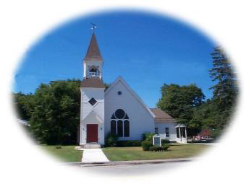


From Woody: It was a treat to have Gail Cormier and Denise Batchelder in our congregation this past Sunday. They were a big part of a wonderful group of kids who were in our youth group at Immanuel United Methodist Church in Waltham during my three years in seminary at Andover Newton. We kind of reconnected when they started watching our online services and it has been really special to get back in touch. They came up last weekend to contribute to the Scouts clothing drive. Hope you get a chance to meet them next time they come up.

We are a growing congregation and we all need to try to reach out and welcome new people and make them feel at home. It has been special to watch the Sunday School start to grow again under the wonderful hand
of Lynn Wawrzyniak and also the formation of a great Junior Choir under Sam Gorton. It is this Sunday that we celebrate Mother's Day and we certainly have lots of wonderful Moms in our church.

Just a little update on the family I mentioned in the sermon two weeks ago. I saw them today. They are anxious to find an apartment that they can afford and if you have any knowledge of rooms a family of three could rent at a reasonable rate please let Caroline Ferguson Wilson or me know.

I also wanted to let people know that there will be a Memorial Service on Saturday, June 7 at 2:00 pm in the church for Nancy Wynall, who was a great part of our town and our church back in the 50's and 60's.

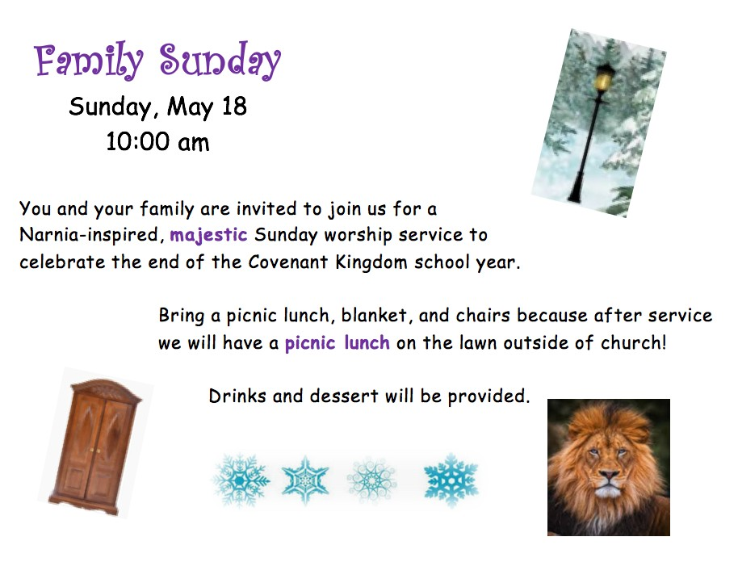


School Supplies for Ukranian Refugees: Additionally, the students of Covenant Kingdom will be collecting school supply-type items to donate to Ukranian Refugee children in Poland. Candy and David Woodbury will be traveling to Poland over the summer to work for a week with under-privileged children. While there, they will distribute our donations of school supply-type items. Examples of items to donate include: colored pencils, skinny and fat markers, coloring books, glue sticks, notebooks of any size, folders, pens of any color, children's scissors, tape, and pencils. (No crayons, please, as they may melt in transit!) Items will be collected throughout the month of May. A donation box will be placed in the church hallway.

We are trying to help the family of three mentioned in Sunday's sermon find housing. It is a family of three and they probably could pay some small amount of rent. Please call Carolyn Ferguson Wilson or Woody if you know of a place....It doesn't have to be in any town in particular. The family is currently in a trailer(not theirs) but needs to move......Woody

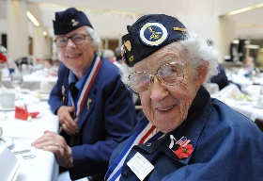
Service Honoring Female Veterans: There will be a service honoring American female veterans killed in action as well as women of the police force and firefighters killed in the line of duty, It will be at 10am on Memorial Day on the Common and is being put on by the Girl Scouts of Troop 99 as well as by a group of local veterans. All are welcome.
This Photo by Unknown Author is licensed under CC BY-ND


Dress A Girl Around the World: This project will be continuing through September. Meetings at the church will be: Saturdays April 19, May 17, June 21, July 19, Aug 16 Sept all Saturdays (6,13, 20, 27). Completed dresses are due to Kristi by September 30. Any questions or if you would like to participate, contact Kristi at 603-486-9910 or email at kris_Kreations@ comcast.net.

Calling those with sergers—who are willing to sew up some infant caps and receiving blankets (already cut out). These will go with the Dress- A-Girl dresses,


QR Code: You can use the QR code below to pay your pledge or other contribution.

QR Code: Or click on this link: https://www.zeffy.com/en-US/donation-form/e47ab025-f0b0-40b4-90e6-f262bb1a29e1


Peace Quote: That old law about "an eye for an eye" leaves everybody blind. The time is always right to do the right thing." Martin Luther King

