Jeremiah “Jerry” F. Kennedy, 81 passed away peacefully on Sunday January 30th in Beverly Hills, FL. He was born on April 19, 1940 in Goffstown, NH. He is the son of the late Joseph and Viola Kennedy of New Boston, NH.

Jerry was a lifelong resident of New Boston, NH and it is in this town where he made his home to raise his family. He loved New Boston dearly and served as a Cemetery Trustee, Planning Board Committee Member, Volunteer Firefighter in his youth and was most proud to be associated with the very distinguished and incomparable New Boston Artillery Company. He was also a proud military veteran and served in the US Army from 1963 – 1965.

Jerry was the unofficial town historian; an annual float building maestro for the 4th of July parades; a master storyteller; a gifted athlete who played on New Boston’s infamous baseball and basketball teams; a great shot with his rifle; one who was always known to use colorful language; he was funny as funny could be; a skilled carpenter, who with his brother Bobby, formed the highly respected construction company “Kennedy Brothers”; an avid golfer who always gave you a mulligan; a dowser who found sources of water for many free of charge; and was most prominently known for making the stiffest and best highball cocktails for all his friends and family to enjoy.

Jerry is survived by his beloved wife of 54 years Jane (Miller) Kennedy; his daughter Kristen de Matteis and her husband Sacha; son Jeffrey P. Kennedy and his wife Shannon; son Jeremiah (Joe) Kennedy and his wife Cheryl. Jerry has six grandchildren and they all affectionately call him Buppa. It is in this role that brought him the greatest joy and happiness. They are his granddaughters Marissa Bourg; Sofia, Olivia, and Eva de Matteis; and his grandsons, Benjamin and Jack Kennedy.

Jerry was raised in a rambunctious household with siblings that he admired and cherished. He was predeceased by his oldest brother Richard Kennedy, and is survived by Richard’s spouse Kay; by his brother Robert and Tess Kennedy; sister Arlene and Willard Dodge; brother Stephen and Nancy Williams; brother Chester Kennedy and Debbie Bortz; and brother-in-law to Leon Miller and his wife Christine. Jerry has many loving nieces and nephews, and happily served as a coach and mentor to many youth throughout town.

MEMORIAL SERVICE
CELEBRATING THE LIFE OF
Jeremiah “Jerry” F. Kennedy
1940-2022

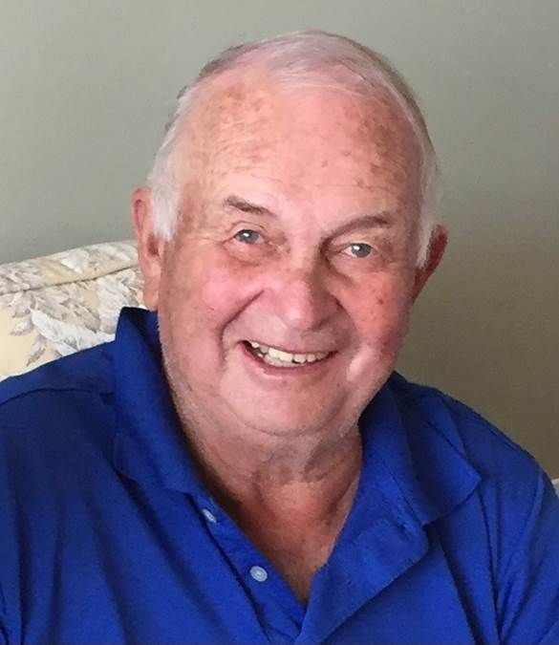

MEMORIAL SERVICE
CELEBRATING THE LIFE OF
JEREMIAH “JERRY” F. KENNEDY
1940-2022

Prelude
Call to Worship
** Hymn—Be Not Afraid (see insert)
Invocation
Scripture: Psalm 23
Anthem—Amazing Grace
Scripture: John 14:1-6
Remembrances
Jeremiah “Joe” Kennedy
Lawrence “Larry” Houghton
Anyone else who wishes to speak
** Hymn – 327 The Old Rugged Cross
Prayer and Benediction
Presentation of United States Flag by U.S. Army
Postlude

Accompanist—Karina Allayne
Soloist—Samantha Hersey Gorton
Producer Virtual Service—Paul Citak
Minister—Woody Woodland

All friends and family are welcome to gather at the Molly Stark Tavern after the services.

Be Not Afraid
You shall cross the barren desert
But you shall not die of thirst
You shall wander far in safety
Though you do not know the way
You shall speak your words to foreign men
And they will understand
You shall see the face of God and live

Be not afraid
I go before you always
Come, follow me and I will give you rest

If you pass through raging waters in the sea
You shall not drown
If you walk amid the burning flames
You shall not be harmed
If you stand before the power of hell
And death is at your side
Know that I am with you through it all

Be not afraid
I go before you always
Come, follow me and I will give you rest

And blessed are your poor
For the kingdom shall be theirs
Blest are you that weep and mourn
For one day you shall laugh
And if wicked men insult and hate you
All because of me
Blessed, blessed are you

Be not afraid
I go before you always
Come, follow me and I will give you rest

St. Louis Jesuits

