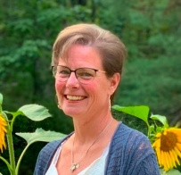
Samantha Hersey Gorton
Is a native of New Boston, Samantha Hersey Gorton has been involved in music and community activities her entire life. She has directed the
Community Church Choir for many years. While attending Wheaton College, she was a member of the a cappella group The Wheatones.

Affectionately known as Ms. Sam by her New Boston Central School students, she has been a teacher in the New Boston School System for many years. She lives in Goffstown with her faithful pup-Tuckerman.

Many thanks to:
Paul Citak and Sam Desrosiers for technical help
Paul Citak, Barbara Woodland, Pattie Garrity for advertisement and program
Roz Spiller for table décor
Karina for her time and expertise
Jamie Boyle for her gracious time and presence.
Woody for his unconditional love and support
Hillside Methodist Church, Goffstown Congregational Church, St. Lawrence church of Goffstown, and the Community Church of New Boston for the delicious pies for fellowship, their time, and passion to share the Christmas story through music to surrounding communities.

Merry Christmas!

CHRISTMAS CANTATA

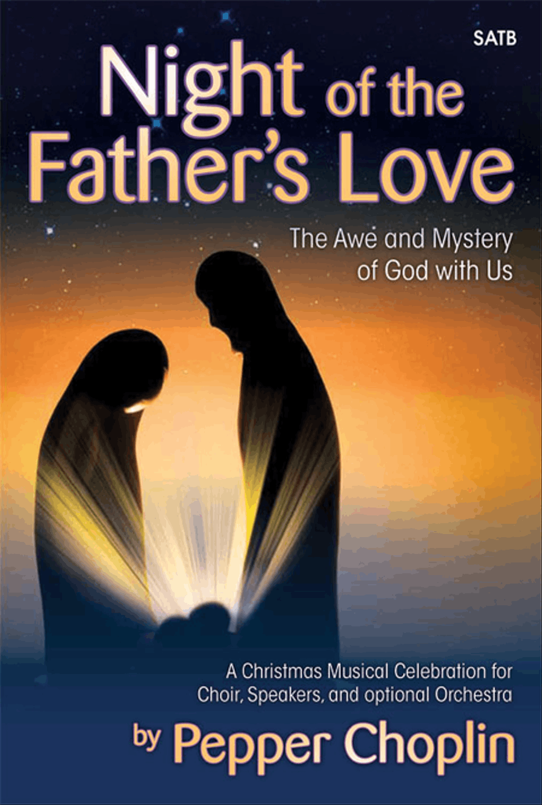

Performed by the combined choirs of the Community Church of New Boston, Hillside Methodist Church, St. Lawrence Church, and Goffstown Congregational Church.
Christmas Cantata Order of Selections
Audience participation is welcome and encouraged during specific parts of this performance. These parts are bolded in the lyrics.
The Coming of the Lord

The Coming of the Lord

Waiting

Angels Are Making Their Rounds

Night of the Father’s Love

The Shepherd’s Song

Seeking the King

Fall on Your Knees

Christ is Born, Nowell!

There are offering plates at the back of the church and in the vestry if anyone would like to contribute to help offset the expenses of this program.

Christmas Cantata Performers
Director Samantha Hersey Gorton
Accompanist Karina Allayne
Narrator Jamie Boyle
Soloists Paul Citak
Janet Cristini
Doug CullenS
Rosalind Spiller

Choir Members
Soprano Tenor
Ellen Anderson CCNB Carey Citak CCNB
Mercedes Cernuda STLC Paul Citak CCNB
Kristi Citak CCNB Dick Jardine CCNB
Cheryl Dancause STLC Gail Parker CCNB
Diane Hinton STLC
Deborah Keiner CCNB Bass
Yvonne LeBlanc STLC Richard Backus CCNB
Rosalind Spiller HMC Donald Chapman CCNB
Doug Cullen GCC (Bass II)
Richard Woodward
Alto
Gloria Chandler CCNB
Carol Hulick CCNB
Louise Robie CCNB
Carolyn Trachim STL
Janet White CCNB

